With effect from 03/04/ 2020

For the immediate attention of all staff and Governors

Camblesforth Primary Academy

This addendum specifies our academy response to Covid-19 and our additional measures that have been put into practice to safeguard our children.

‘Schools and colleges should, as far as is reasonably possible, take a whole institution approach to safeguarding. This will allow them to satisfy themselves that any new policies and processes in response to COVID-19 are not weakening their approach to safeguarding or undermining their child protection policy.’
‘It is important schools and colleges (led by a DSL or deputy, wherever possible) review and revise their child protection policy and keep it under review as circumstances continue to evolve. In some cases, a COVID-19 annex/addendum that summarises any key COVID-19 related changes might be more effective that re-writing and re-issuing the whole policy’
Coronavirus (COVID-19): safeguarding in schools, colleges and other providers DfE 27/03/20

Context
In response to COVID guidance 27/03/20 the specific contingency plans and awareness raising measures are outlined in this addendum to the existing school Child Protection and Safeguarding (CP&S) arrangements. As such, these contingency arrangements are obligatory and must be followed by all staff. We all have a shared responsibility for CP&S.

Whilst the Child Protection & Safeguarding arrangements and responsibilities outlined in the Ebor Academy Trust strategic policy remain in place, in the current context, specific and vital additional strategies are required to be implemented to ensure continuity of support for vulnerable children and others attending school at this time.

We will endeavour to do all that we can to continue to provide a safe and caring environment for all children and staff attending school and to support children not attending as much as practicably possible.

We recognise that some of the children attending school are our most vulnerable and may be at even greater risk or stress at this time due to family problems or mental health concerns or other issues.

Staff are aware through this time of national crisis and school closures of the potential significant impacts on a child/young person’s mental health and wellbeing. Staff are ensuring that if they have such concerns about a child, be that child attending the provision or otherwise, they are able to gather all concerns/disclosures and record and report them through the usual channels. Any indicators that a child is potentially at risk or vulnerable, through disclosures or behaviours presented through online classrooms and remote teaching tools, must still be collated and reported in the usual manner. Where schools are operating rotating leadership teams or remote DSL support then all staff should be clear on who they report disclosures and concerns to on a daily basis.

The leadership team and governors also are aware and sensitive to the pressures that staff, including themselves, are under at this time and recognise that they require support in order to be able to support the children they care for at school. This is particularly the case for staff such as DSLs, SENDCO, pastoral teams and Designated LAC teachers who have such an important role to play in supporting our most vulnerable children.

- Updated advice from the local safeguarding partners or MAT (include contact numbers and referral procedures if different to your usual reporting arrangements)
  - Due to COVID19 the Ebor Academy Trust has assigned the strategic responsibility for safeguarding to the Trust Safeguarding Lead who can act, where needed, as a remote DSL for schools.
1.2 The Trust Safeguarding Lead and Executive Headteacher for each school are also available to support with complex cases and offer extra balances and checks in relation to the safety of all pupils.
1.3 Within each local authority area, a number of school based staff are working as part of a co-ordinated response team under the guidance of the Trust Safeguarding Lead, offering the MAT schools in the locality additional advice and capacity to ensure all safeguarding arrangements remain compliant and operational. The Trust has assimilated a central register of all children in its schools identified as critically vulnerable. This is only accessed by the Trust Safeguarding lead and the CEO. This includes a child on a child protection plan, child in need, child looked after, or a child with an EHCP. This allows for contingencies to be made if ever a school does not have its DSL or DDSL for a short period of time.

- Updated advice received from local authorities regarding children with education, health and care (EHC) plans, the local authority designated officer and children’s social care, reporting mechanisms, referral thresholds and children in need.
2.1 Children with an EHCP plan have been offered a place in school in line with the government stipulations on school closures. In mutual agreement with the school leadership and parent, the child is only accessing the provision if it is decided that it is the right thing for that child’s welfare and wellbeing to attend the setting.
2.2 GB/SEN team will be making weekly contact and SEND children are accessing the provision on a reduced basis etc. etc.)
2.3 Children identified as vulnerable and who have a social worker have a school place allocated should they wish to access it. However, each school's leadership team is ensuring that the appropriate number of welfare phone calls/pavement home visits/and liaison with the family are made. Where it is needed, alternative and bespoke provision is being put in place for these children and they are constantly being monitored. Regular liaison with Children's Social Care is in position for these children.
2.4 KT/TR will investigate support which can be provided as part of our pastoral team. Sharing key information staff can share on the google classroom.
2.5 The DSL/DDSL is still attending all meetings that are required for children who are S47 or S17. On the rare occurrence due to the COVID19 position that the school does not have capacity to fulfil its duty to attend statutory meetings, the Trust Safeguarding Lead or Executive Headteacher is able to represent the school and ensure all information is shared and assimilated.

- Revised procedures for staff and volunteers if they have any concerns about a child.
3.1. In order to minimise the risk of the spread of infection, protecting the children, its staff and the local community through the period of school closures, the MAT does not foresee that volunteers will be coming onto the school site. Should this change then the school will ensure the volunteer adheres to all the usual policies and procedures that are in place to work safely and safeguard children and staff.
3.2 If staff have a concern about a child who is in the emergency provision, or is accessing through the remote online platforms, then the school’s usual systems are in place for reporting concerns. Depending on the nature of the concern, DSL will make contact with the family if appropriate.
3.3 If children are not accessing home learning, teachers must pass this information onto GB/DC from following the flow chart.
3.4 If the concern raised seems to meet the threshold, the DSL will make a referral to Early Help or Social Services following the normal channels.

- Emphasising the continued importance of all staff acting immediately on any safeguarding concerns.
4.1 Staff will monitor which children are accessing online resources and the Google Classroom. Staff will also make Keeping in touch emails and phone calls with families and children.
4.2 If staff are still not able to get in contact with the family over a pre agreed period of time then they will inform the DSL and deputy DSPL
4.3 If there is a continued failure to make contact with the family, the SLT/DSL will make contact at the house following social distancing procedures. Staff will never attend alone, nor will staff travel together in the same car. Where a child or family has become unobtainable and there are either identified previously known risks, or a prolonged period of absence from the online portals, the DSL will make a decision to refer in to social care if they feel it meets the threshold. We will also involve other agencies such as PCSOs if it’s felt appropriate to make welfare checks.

- Key Safeguarding leads: contact details and contingency arrangements.
5.1 DSL – Dave Card
5.2 Deputy DSL -Gwyneth Beaumont
5.3 Headteacher -Dave Card
  - Safeguarding Governor- Jane Breach
  - The Trust DSL
  - Executive Headteacher

- The continued importance for school and college staff to work with and support children’s social workers and the local authority virtual school head (VSH) for looked-after and previously looked-after children.
6.1 We will keep in regular contact with Social workers and the virtual school through email.
6.2 LAC reviews and any paperwork that needs to be completed will be done digitally or over the phone.
6.3 We also keep in contact with the LAC if they are not already in school and do regular keeping in touch calls and emails.

6.4 We will attend all child protection meetings, core groups, MARACS, and strategy meetings remotely.

- Peer on peer abuse - given the very different circumstances schools and colleges are operating in, a revised process may be required for managing any report of such abuse and supporting victims. Through the period of the school closure the school staff will remain vigilant for all external factors that could be impacting on a pupil’s emotional health (the principles as set out in part 5 of KCSIE should continue to inform any revised approach).
7.1 Staff will be closely monitoring any online interactions that they are having with children.
7.2 Schools will be building online and remote systems for carrying out emotional check ins and trying to assess a child’s welfare through keeping in touch phone calls and messages through each school’s online management information system for parental communication.
7.2 Children will use a whole school approach for online check in

- What staff should do if they have concerns about a staff member who may pose a safeguarding risk to children (the principles in part 4 of KCSIE will continue to support how a school or college responds to any such concerns).
8.1 Staff will continue to follow our school safeguarding policy and whistleblowing policy
8.2 We have received advice from Rebecca McGuinn on how staff should keep themselves safe when contacting parents and families as well as suggested prompts, guides and scripts for engaging with families throughout COVID19
8.3 The head teacher or senior leader has access to all online Classrooms and can monitor work provided and what staff and children are saying to each other through this platform.

- Arrangements to support children the school are concerned about who do not meet the ‘vulnerable’ definition therefore are not attending the provision.
9.1 Children that are known to be vulnerable but do not meet the criteria will be contacted additionally by GB.
9.2 The SLT and Pastoral team will meet weekly (remotely or otherwise) to review the vulnerable register and ensure that the correct children are still being targeted for welfare calls or pavement visits.
9.3 Class teachers have a system to ensure they are checking in with each child remotely at least once a week and those who are classed as vulnerable have a key worker
9.4 Risk assessments are in place and specific plans overseen and managed by the Wellbeing team are in place to support specific children’s wellbeing on a remote basis through a nurture based google classroom
9.5 The Trust welfare response team meet weekly with the Trust Safeguarding Lead to review any complex cases across the Trust, and to ensure systems continue to be reviewed, scrutinised and reflected upon.

- The school’s arrangements to ensure online safety for the staff who are working via online platforms as a means of teaching and learning or establishing welfare checks. Ensuring the online safety of children who may have access to school's technology such as a Chromebook.
10.1 We will continue to provide a safe environment, including online. This includes the use of online filtering & blocking of inappropriate material and interactions and constant monitoring by staff of children’s online activity. We are not delivering live video streaming to pupils in the form of live lessons. Where it is appropriate we may access some video conferencing provided this is always done on the school site, linked to the school network and there are always two two adults present.
10.2 All staff who interact with children, including online, will continue to look out for signs a child may be at risk. Any such concerns should be dealt with following the Child Protection procedures as above and where appropriate referrals will be made to Children’s Social Care.
10.3 We will ensure any use of online learning tools and systems is in line with privacy and data protection/GDPR requirements.
10.4 We will maintain communication with parents and ensure that they are signposted via the school website to sources of advice particularly in respect of online safety at this time of increased use to support learning and social interaction.

Review of policy Addendum:

We will constantly review the operation of this addendum and make adjustments if identified and on receipt of further Government, DfE, LA or other advice and updates. We also remain compliant with all local authority reporting arrangements, and multi-agency safeguarding hubs.

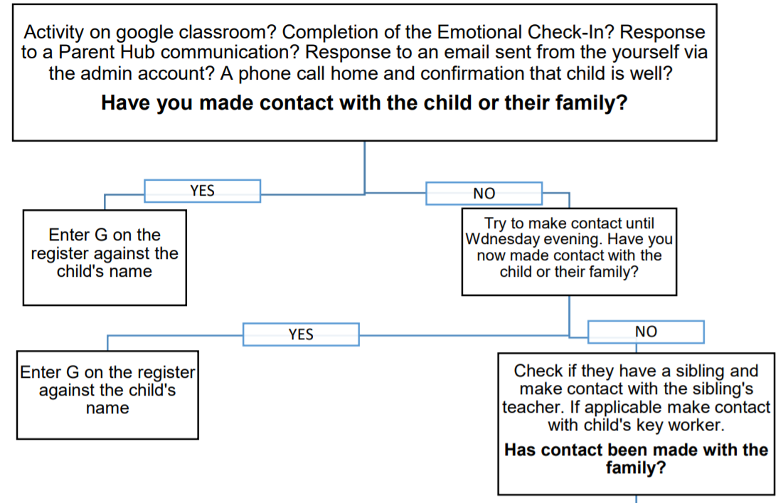
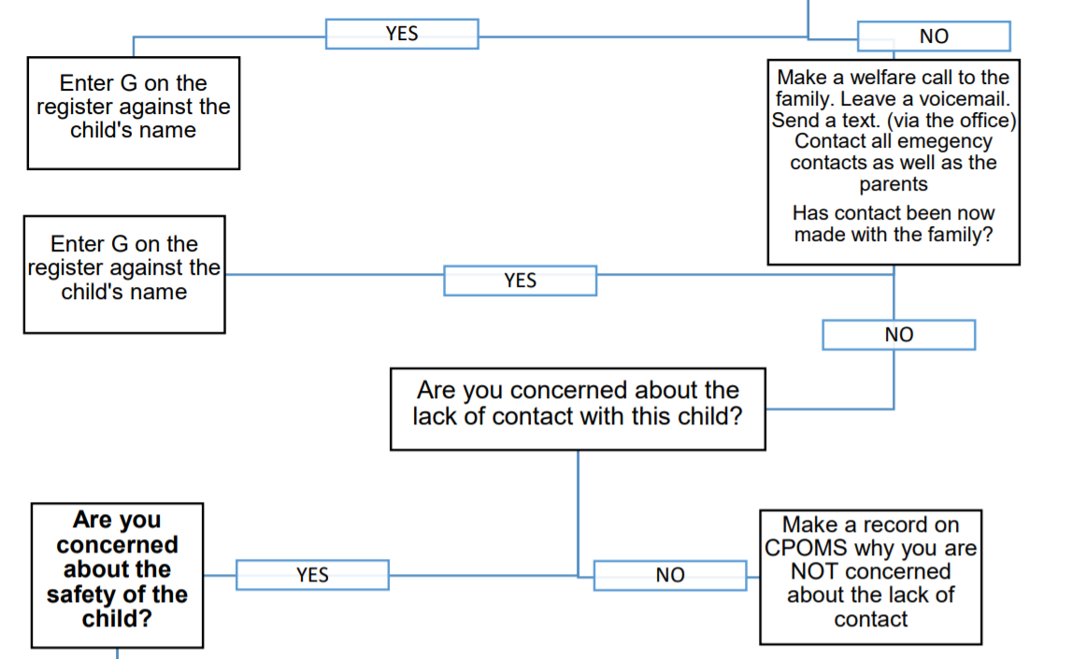
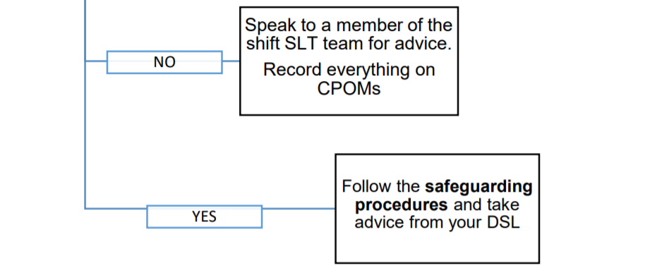
Specific to Camblesforth
SLT- Text DC/GB and ask to call back with specific safeguarding concern.

