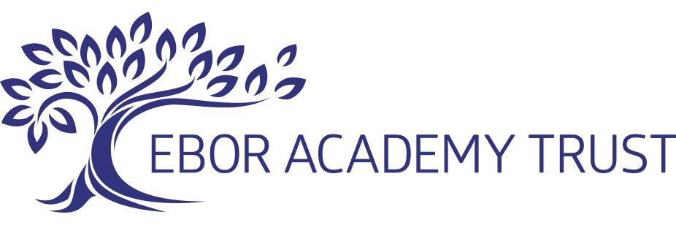

29

Relationships and Sex Education Policy

Approved by: Ebor Academy Trust Board of Trustees

Approval Date: May 2022

Review Period: May 2022

Review Date: May 2024

Author: Rebecca McGuinn (ESIT Lead - Behaviour, Safeguarding & Wellbeing)
Date Created/updated: May 2022
Version Number: 2

Contents:

1. Introduction 3
2. Policy Intent 3
3. What Is Relationship and Sex Education? 3
4. Statutory Expectations 3
5. Policy Consultation 3
6. Aims and Objectives for Relationship and Sex Education 4
7. Sex Education 5
8. Parents’ right to withdraw 5
9. The organisation of Relationship and Sex Education 5
10. The Role of Visitors in regards to RSE 6
11. SEND Pupils and Vulnerable groups 6
12. Safeguarding Children 6
13. Sexual Identity and Sexual Orientation 7
14. Controversial and Sensitive Issues 7
15. Dealing with Difficult Questions 7
16. Monitoring & Evaluation 7
Appendix 1: Additional guidance for supporting children 8
Appendix 2: RSE Curriculum Plan 10
Appendix 3: A Guide for parents 11
Appendix 4: Parent form: withdrawal from sex education within RSE 13

- Introduction

As an academy group we have four clear drivers. Excellence, Belonging, Opportunity, Respect.

Excellence – We work to inspire and instil in others, the desire to be the best we can.
Belonging – To work together as a community, having a unique and valued part to play within our academy alliance.
Opportunity – To give, and be given, the opportunities to grow, flourish, and celebrate success.
Respect – To value, respect and care for others and ourselves.
- Policy Intent
Camblesforth’s vision is to prepare our children to be happy, successful and responsible citizens in the future. Our intent is to develop outward-looking pupils, who are able to engage in learning both about themselves and about the wider world.

We believe our Health, Relationships and Sex education programme contributes to the vision and intent and is also underpinned with our values and ethos. The aim of RSE is to provide children with age appropriate information, explore attitudes and values and develop skills in order to empower them to make positive decisions about their health related behaviour.

This should take place with consideration of the qualities of relationships within families. Every child is entitled to receive RSE regardless of ethnicity, gender, religion, age, culture, disability, sexuality, language, special educational needs, disadvantaged and looked after children.
It is our intention that all children have the opportunity to experience a programme of RSE at a level which is appropriate for their age and physical development with differentiated provision if required.

- What Is Relationship and Sex Education?

Sex and Relationship Education is lifelong learning about physical, sexual, moral and emotional development. It is about the understanding of the importance of stable and loving relationships, respect, love and care for family life. It involves acquiring information, developing skills and forming positive beliefs, values and attitudes.

- Statutory Expectations
Relationships and Health Education is compulsory in Primary Schools. We must provide relationships education to all pupils as per section 34 of the Children and Social work act 2017.
For Primary Schools – Sex education is not mandatory although they must teach the elements of sex education contained in the science curriculum. The National Curriculum for Science includes content about human body parts, growth, puberty and reproduction. Parents do not have the right to withdraw from this aspect of the curriculum. Primary Schools can decide to teach some aspect of Sex Education if they should deem it to be important in their context.
In teaching RSE, we must have regard to the statutory guidance from the DfE www.gov.uk/government/publications/relationships-education-relationships-and-sex-education-rse-and-health-education issued by the secretary of state as outlined in section 403 of the Education Act 1996.
The new curriculum will be compulsory from September 2020. Schools should start teaching from that date if they meet the statutory requirements. If they are not ready, or are unable to meet the requirements, they should begin teaching by at least the start of the summer term 2021.
Schools are required to comply with relevant requirements of the Equality Act 2010. Further guidance is available for schools in The Equality Act 2010 and schools advice.
- Policy Consultation
We are committed to working in partnership with parents and carers on the delivery of the RSE curriculum, we want our parents and carers to feel included and involved in how we are working with their children when educating them on sensitive and thought provoking topics featured within this curriculum. We will always share information with parents in an informative and consultative way, that allows for a dialogue between home and school in order to strengthen the practice and provision we can deliver to our children.

This policy is being developed in consultation with staff, pupils and parents/ carers. The consultation process involved the following steps:

1. Staff consultation – all school staff were given the opportunity to look at the policy and make recommendations

2. Parent/stakeholder consultation – parents and any interested parties are invited to respond to the draft policy by contacting the school. The publication of supporting resources and materials for the ‘puberty’ and ‘growing up’ sessions for KS2 is made available to parents prior to the delivery of these. We work to incorporate parental feedback into the development and delivery of these lessons.

3. Pupil consultation – we investigated what pupils in our community want from their RSE lessons and the areas of sensitivity, risk and development that is relevant to them and the context in which we teach.

This policy will be available to parents on request as well as via our website.

- Aims and Objectives for Relationship and Sex Education

The aim of RSE is to provide children with age appropriate information, explore attitudes and values and develop skills in order to empower them to make positive decisions about their health related behaviour. This should take place with consideration of the qualities of relationships within families.

- The objectives of Sex and Relationship Education are:

- To provide the knowledge and information to which all pupils are entitled. To clarify/reinforce existing knowledge.

- To raise pupils’ self -esteem and confidence, especially in their relationships with others.

- To help pupils understand their sexual feelings and behaviour, so they can lead fulfilling and enjoyable lives.

- To help pupils’ develop skills (language, decision making, choice, assertiveness) and make the most of their abilities.

- To provide the confidence to be participating members of society and to value themselves and others. To help gain access to information and support.

- To develop skills for a healthier safer lifestyle.

- To develop and use communication skills and assertiveness skills to cope with the influences of their peers and the media.

- To respect and care for their bodies.

- To be prepared for puberty and adulthood.

- RSE focuses on giving young people the information they need to help them develop healthy, nurturing relationships of all kinds including:

- Families
- Respectful relationships, including friendships
- Online and media
- Being safe
- Intimate and sexual relationships, including sexual health
These areas of learning are taught within the context of family life taking care to ensure that there is no stigmatisation of children based on their home circumstances (families can include single parent families, LGBT parents, families headed by grandparents, adoptive parents, foster parents/carers amongst other structures) along with reflecting sensitively that some children may have a different structure of support around them (for example: looked after children or young carers).

- Sex Education
At Camblesforth School we will be continuing to provide some additional content on sex education to meet the needs of our pupils in line with all primary schools within our trust. We already choose to teach some aspects of sex education and will continue to do so in line with DfE advice that all primary schools should have a sex education programme tailored to the age and the physical and emotional maturity of the pupils. It should ensure that both boys and girls are prepared for the changes that adolescence brings and – drawing on knowledge of the human life cycle set out in the national curriculum for science - how a baby is conceived and born.
At Camblesforth School we will teach this in Year 6. We will consult parents before the final year of primary school about the detailed content of what will be taught. This process will include offering parents support in talking to their children about sex education and how to link this with what is being taught in school.

In line with statutory policy, parents have a right to withdraw their children from this aspect of the curriculum (as detailed more fully below).
- Parents’ right to withdraw
Parents do not have the right to withdraw their children from relationships education.
Parents have the right to withdraw their children from the [non-statutory/non-science] components of sex education within RSE.
Requests for withdrawal should be put in writing using the form found in Appendix 4 of this policy and addressed to the head teacher. We will invite you to talk through your concerns, explain our school’s rationale for RSE and invite you to review some of the materials we hope to use. Withdrawing your child from sex education remains a statutory right as a parent or legal guardian.
Alternative work will be given to pupils who are withdrawn from sex education.
- The organisation of Relationship and Sex Education

Our school’s overall aim is to give all children the best possible opportunities to grow and develop as people in their own right during their time at Camblesforth Primary Academy.

Relationship and sex education is delivered through science, PSHE, Citizenship and circle time. Sex and relationship education is taught by classroom teachers, teaching assistants and if appropriate, outside visitors such as the school nurse.

A range of teaching methods which involve children’s full participation are used to teach sex and relationship education. These include use of video, discussion, looking at case studies, drama and role play.

Resources to teach sex and relationship education may include fiction, reference books, leaflets and extracts from video clips. Sex and relationship education is usually delivered in mixed gender groups; however, there may be occasions where single gender groups are more appropriate and relevant.

The website which we use to teach children about changing adolescent bodies and reproduction is: Busy Bodies Parents will be invited to view these videos and ask any questions before they are shared with the children in school.

There are 6 videos on this website. 5 of these may be shown without parental consent as they fall within the Health and Relationships Education programme. One of the videos (‘How babies are made’) is part of the Sex Education programme and therefore requires parental consent (see Parental Consultation and Rights below)

For more information about our RSE curriculum plans (See Appendix 2)

- The Role of Visitors in regards to RSE
Visitors are invited into school because of the particular expertise or contribution they are able to make. All visitors are familiar with and understand the school’s RSE policy and work within it. Where it is deemed appropriate the school may call upon specialist or guest speakers to contribute to the delivery of lessons to enhance children's learning experience.

- SEND Pupils and Vulnerable groups
Relationships Education, Sex and Health Education must be accessible for all our pupils. This is particularly important when planning teaching for pupils with special educational needs and disabilities. High quality teaching that is differentiated and personalised will be the starting point to ensure accessibility for those pupils who do have additional needs.

At Camblesforth school we are aware that some pupils are more vulnerable to exploitation, bullying and other issues due to the nature of their SEND. Relationships Education and RSE can also be a subject that provokes much thought and discussion for pupils. For the more vulnerable pupils; for example those with Social, Emotional and Mental Health needs or learning disabilities. We are aware that making adaptations, pre-teaching and regular liaison and consultation with those pupils will be needed.

- Safeguarding Children

When teaching any sensitive topic, such as RSE which deals with family life, safe and appropriate touching, personal body parts and healthy relationships, we recognise the potential to uncover incidents of abuse through children’s disclosures.

All members of staff who deliver any of our Relationship or Sex Education Programme, have statutory training around safeguarding children and are all aware of our school’s safeguarding policy and procedures in the case of a disclosure or suspicion of a safeguarding concern.

We recognise that for children who may be vulnerable due to past or present abuse or changes in family situations, this type of work, whilst it may be sensitive, there may be needs to adapt the programme or offer additional support. It is also a protective factor in preventing further abuse, to help them make sense of their experiences and essential to help them develop skills and resilience to keep them safe in future.

- Sexual Identity and Sexual Orientation

Camblesforth Primary School believes that SRE should meet the needs of all pupils regardless of their developing sexuality and be able to deal honestly and sensitively with sexual orientation, answer appropriate questions and offer support. Bullying is dealt with strongly yet sensitively. The school liaises with parents on this issue to reassure them of the content and context.

- Controversial and Sensitive Issues
Staff are aware that views around RSE related issues are varied. However, while personal views are respected, all RSE issues are taught without bias. Topics are presented using a variety of views and beliefs so that pupils are able to form their own, informed opinions but also respect others that may have a difference of opinions.

- Dealing with Difficult Questions

Both formal and informal RSE arising from pupils’ questions are answered according to the age and maturity of the pupil concerned. Questions do not have to be answered directly, and can be addressed individually later. The school believes that individual teachers must use their skill and discretion in this area and refer to the member of staff responsible for safeguarding if they are concerned. (See Appendix 1)
- Monitoring & Evaluation
The senior leadership team will work with subject leaders to monitor the provision of RSE across the school. This will be completed a minimum of once a term and will include learning walks, CPD, pupil perceptions and book monitoring. Pupils' perception evaluations will be used to monitor the progress of pupils' understanding of RSE. It is the responsibility of each leadership team to ensure that pupil voice and parental consultation remains at the heart of the RSE core offer.
Appendix 1: Additional guidance for supporting children
Answering Children’s Questions:

- We are aware that children are likely to have many questions that may occur at any time. Children tend to ask whatever is on their mind. We see this as a positive point and a sign that we have created a safe environment where children feel empowered to feed their natural curiosity and learn about themselves, their bodies and the world around them. However, we acknowledge that some parents may feel uncomfortable about how particular questions may be dealt with in class.

- We believe children are better off receiving honest, open answers from safe adults in their lives, rather than it being left to the internet or older children with a smartphone. In the age of information, where children in primary have access to tablets, smartphones and the internet (often unsupervised) it is essential that we help children to recognise they are able to ask questions without judgement rather than searching for answers on the internet.

- By tackling the topic in a matter of fact manner, without embarrassment means that we take the mystic allure out of the topic, making sex no longer the secret taboo. However uncomfortable a proposition that may be, it is far better than the alternative. For children these questions are not rude, they are simply signs of a healthy and natural curiosity. We can stop the topic becoming taboo and embarrassing and removing the stigma before it has had a chance to form.

- We believe that if children ask a question they deserve an answer. If ignored they merely build unnecessary barriers, making children think they have done something wrong; they are unlikely to ask again, and are instead left to seek their answers from less reliable or child friendly sources, due to shame. However uncomfortable the question may be, the thought is already in their head. it is much better we as safe adults take responsibility and tackle the question safely and age appropriately.

- Staff have received training as to how to deal with children’s questions age appropriately. This will be done consistently across the school as follows:

- Children will be praised for asking questions. We wish to encourage children to seek answers from safe adults.

- If a question is relevant to the whole class, we will answer it to the whole group. However, as with any other subject, there may occasionally, be the need to

- Differentiate depending on children’s knowledge and experience. Some children may need additional information or support compared to others.

- If a child asks a question that is not necessarily suitable for the entire class, we will respond, by saying: “that is fantastic question, hold that thought, I am going to set everyone some work and I will come and talk to you and answer your question in a minute when everyone else is working.”

- If the member of staff doesn’t have an answer or doesn’t know, they will say so.

- There is no shame in not knowing the answer, but the member of staff should try to help the child to find the answer later.

- If the member of staff is not sure how best to answer a particularly tricky question, our suggested response is: “That is a brilliant question, I would like to give you an equally brilliant answer, so let me have a think about it and once I know the best way to explain it clearly I will come back to you”

- This will allow teaching staff time to think, seek help, advice or support from colleagues, or to speak to senior management.

- If a child asks a question we know parents may be uncomfortable with, staff may choose to delay answering the question (as above) until they have spoken to the parent/carer if possible and talk through their response.
- Teachers will answer questions, openly, honestly, scientifically and factually without relying on their own personal beliefs. Teachers will not be expected to answer personal questions about themselves or to ask direct personal questions of their students that could make either parties vulnerable.

Appendix 2: RSE Curriculum Plan
The following table shows how the delivery of Health Education, Relationship Education and Sex Education programmes are planned to fit in to Camblesforth’s 2-year rolling programme of learning

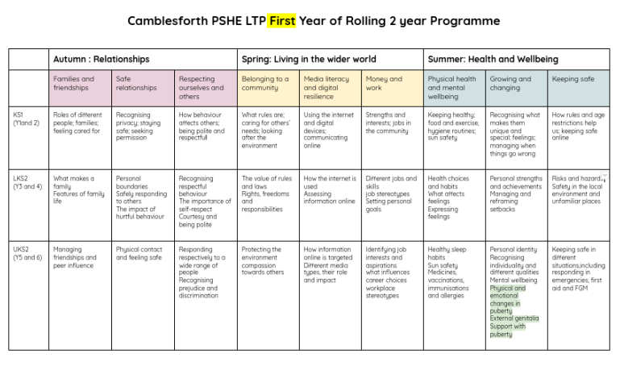

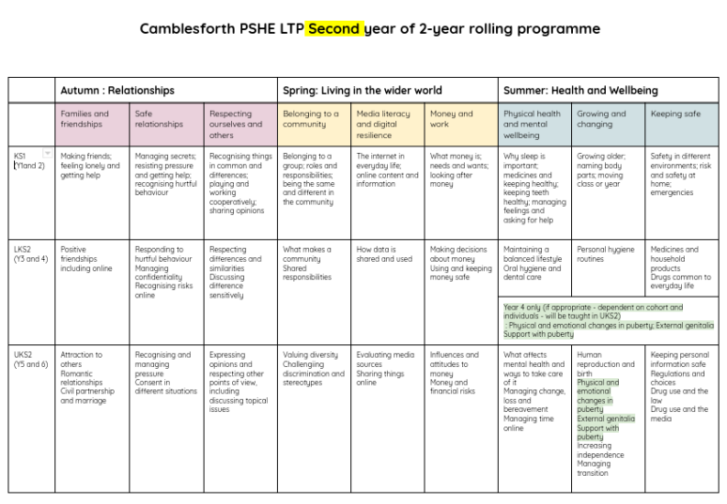
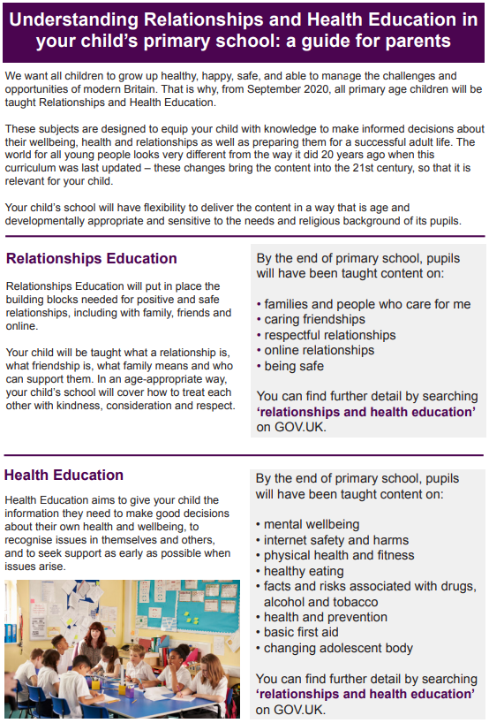
Appendix 3: A Guide for parents

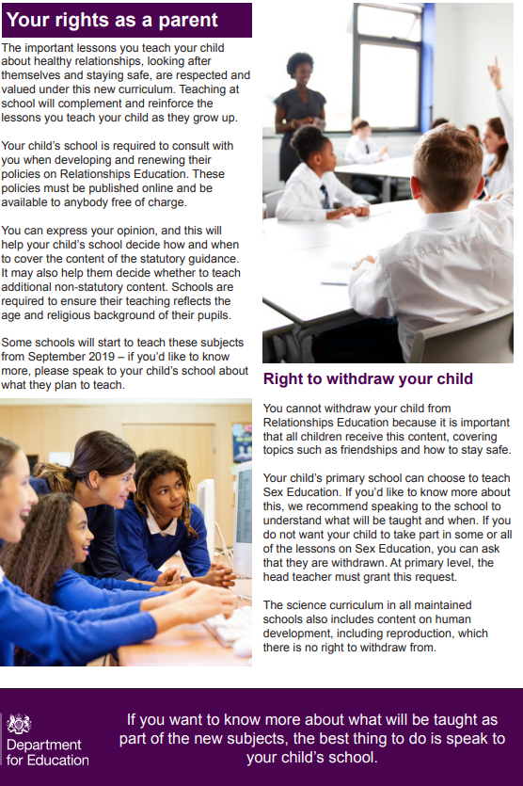
Appendix 4: Parent form: withdrawal from sex education within RSE
TO BE COMPLETED BY PARENTS
Name of child |  | Class
Name of parent |  | Date
Reason for withdrawing from sex education within relationships and sex education
Any other information you would like the school to consider
Parent signature

TO BE COMPLETED BY THE SCHOOL
Agreed actions from discussion with parents
Staff Signature

